**Collège de Bois de Boulogne**

**Labo – Pratique mlflow**

**OBJECTIF**

1. Ouvrir une fenetre de commande et ouvrir un environnement conda

conda create -n mlflow_env

conda activate mlflow_env

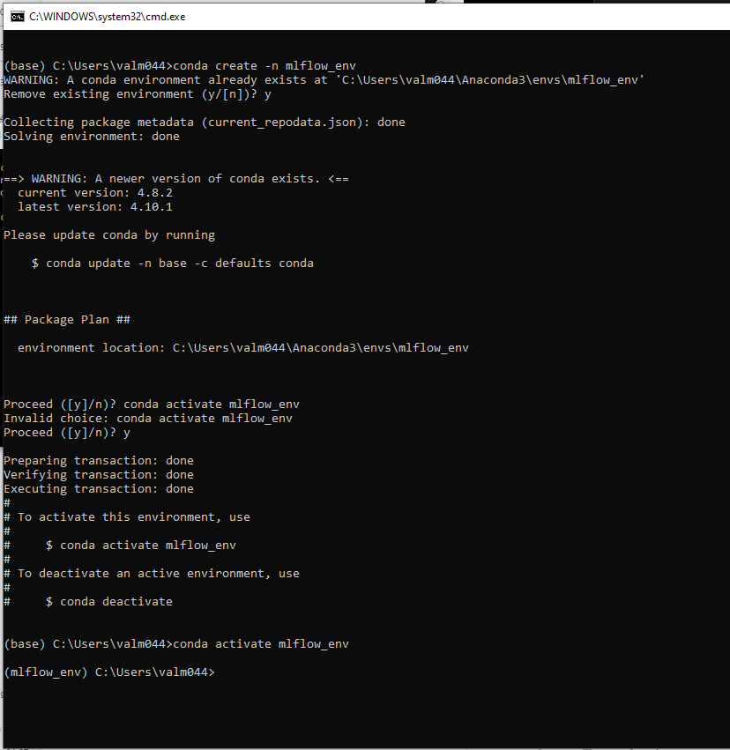

staller la librairie mlflow

conda install python

pip install mlflow

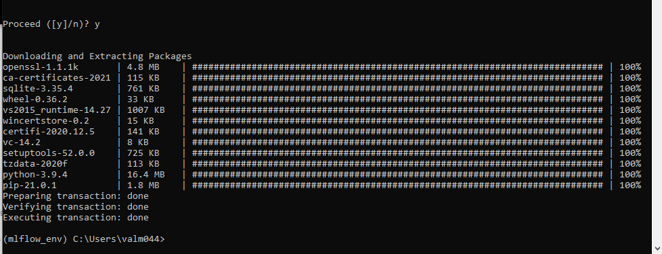

1. Vérifier que MLflow est bien installé

mlflow --help

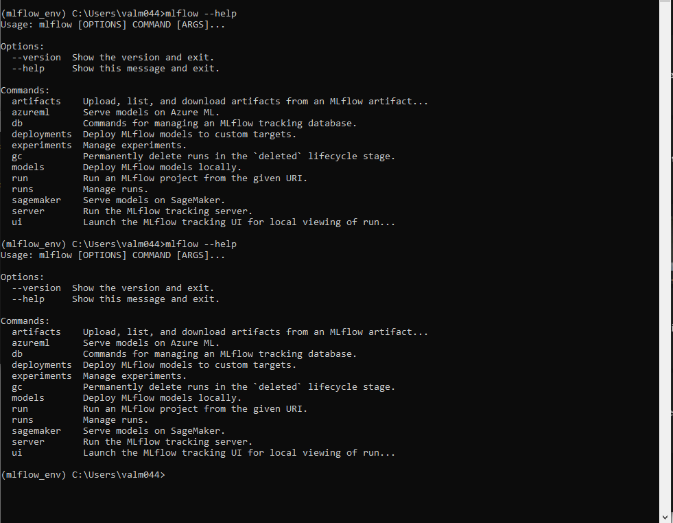

1. Exécuter l’interface UI de mlflow

**mlflow server --backend-store-uri sqlite:///mlflow.db --default-artifact-root ./artifacts --host 0.0.0.0**

Note: à vérifier (suggestion de Zakaria)

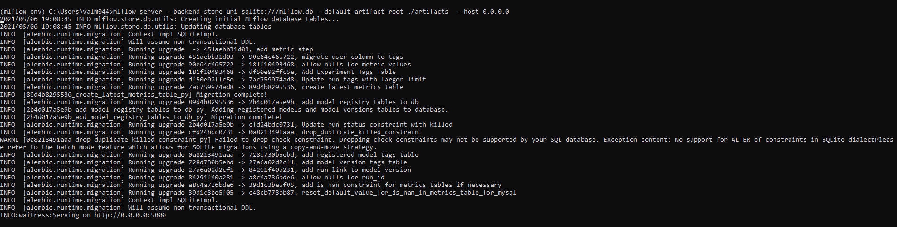

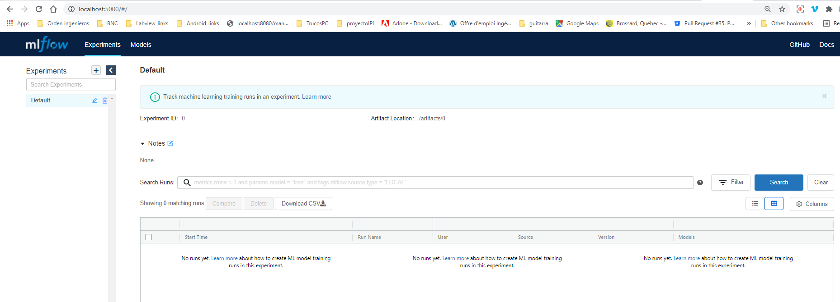

Create experiment :

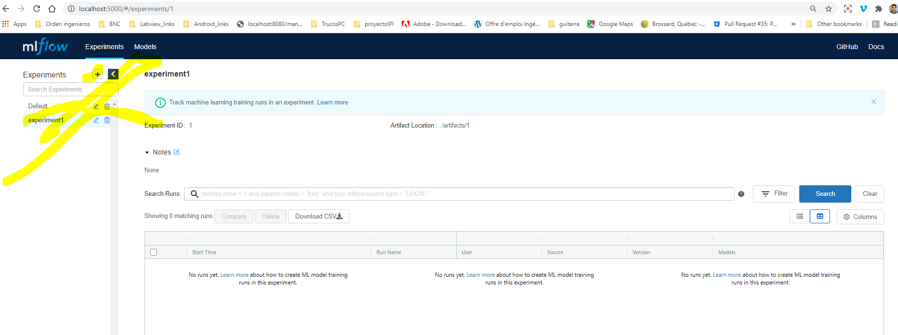

1. Ouvrir un jupyter notebook
2. Utiliser le code suivant :

# The data set used in this example is from http://archive.ics.uci.edu/ml/datasets/Wine+Quality

# P. Cortez, A. Cerdeira, F. Almeida, T. Matos and J. Reis.

# Modeling wine preferences by data mining from physicochemical properties. In Decision Support Systems, Elsevier, 47(4):547-553, 2009.

#! pip install --user mlflow

import os

import warnings

import sys

import pandas as pd

import numpy as np

from sklearn.metrics import mean_squared_error, mean_absolute_error, r2_score

from sklearn.model_selection import train_test_split

from sklearn.linear_model import ElasticNet

import mlflow

import mlflow.sklearn

import logging

logging.basicConfig(level=logging.WARN)

logger = logging.getLogger(__name__)

def eval_metrics(actual, pred):

rmse = np.sqrt(mean_squared_error(actual, pred))

mae = mean_absolute_error(actual, pred)

r2 = r2_score(actual, pred)

return rmse, mae, r2

if __name__ == "__main__":

warnings.filterwarnings("ignore")

np.random.seed(40)

# Read the wine-quality csv file from the URL

csv_url =\

'http://archive.ics.uci.edu/ml/machine-learning-databases/wine-quality/winequality-red.csv'

try:

data = pd.read_csv(csv_url, sep=';')

except Exception as e:

logger.exception(

"Unable to download training & test CSV, check your internet connection. Error: %s", e)

# Split the data into training and test sets. (0.75, 0.25) split.

train, test = train_test_split(data)

# The predicted column is "quality" which is a scalar from [3, 9]

train_x = train.drop(["quality"], axis=1)

test_x = test.drop(["quality"], axis=1)

train_y = train[["quality"]]

test_y = test[["quality"]]

#alpha = float(sys.argv[1]) if len(sys.argv) > 1 else 0.5

#l1_ratio = float(sys.argv[2]) if len(sys.argv) > 2 else 0.5

alpha = 0.67#à changer

l1_ratio = 0.3#à changer

#Note de Zakaria

**mlflow.set_experiment(experiment_name='experiment1')**

**mlflow.set_tracking_uri("http://localhost:5000")**

with mlflow.start_run():

lr = ElasticNet(alpha=alpha, l1_ratio=l1_ratio, random_state=42)

lr.fit(train_x, train_y)

predicted_qualities = lr.predict(test_x)

(rmse, mae, r2) = eval_metrics(test_y, predicted_qualities)

print("Elasticnet model (alpha=%f, l1_ratio=%f):" % (alpha, l1_ratio))

print(" RMSE: %s" % rmse)

print(" MAE: %s" % mae)

print(" R2: %s" % r2)

mlflow.log_param("alpha", alpha)

mlflow.log_param("l1_ratio", l1_ratio)

mlflow.log_metric("rmse", rmse)

mlflow.log_metric("r2", r2)

mlflow.log_metric("mae", mae)

mlflow.sklearn.log_model(lr, "model")

1. Procéder à son exécution (changer les valeurs indiquées dans le code)

alpha = 0.67

l1_ratio = 0.3

1. Vérifier sur l’interface MLflow que vous avez un suivi de vos exécutions

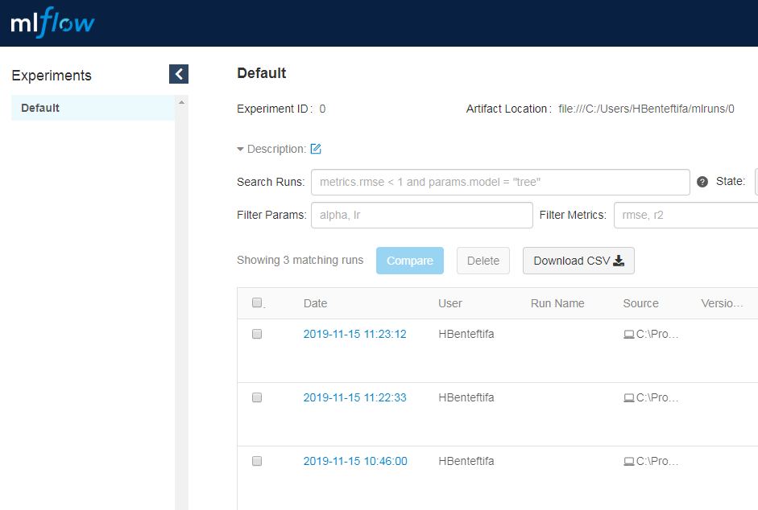

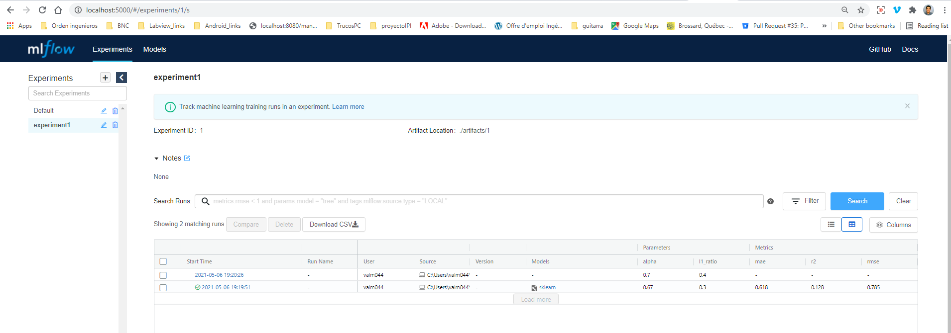

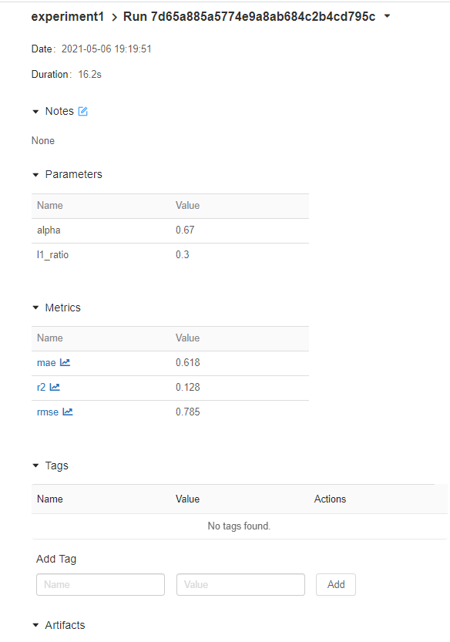

**Références**

<https://thegurus.tech/posts/2019/06/mlflow-production-setup/>

<https://mlflow.org/docs/latest/tutorial.html>